Design binary converters homework

Paul Collado

Department of Computer Science

Montclair State University

CMPT281

Theory of Digital Machines

03/04/2015

1. Problem: Design a binary converter to convert a 3-bit binary number to a 1’s Complement
2. Solution: I will use the steps learned in class to design a circuit.
3. Create truth table:

|  |  |  |  |  |  |
| --- | --- | --- | --- | --- | --- |
| **A** | **B** | **C** | **A 1st** | **B 1st** | **C 1st** |
| 0 | 0 | 0 | 1 | 1 | 1 |
| 0 | 0 | 1 | 1 | 1 | 0 |
| 0 | 1 | 0 | 1 | 0 | 1 |
| 0 | 1 | 1 | 1 | 0 | 0 |
| 1 | 0 | 0 | 0 | 1 | 1 |
| 1 | 0 | 1 | 0 | 1 | 0 |
| 1 | 1 | 0 | 0 | 0 | 1 |
| 1 | 1 | 1 | 0 | 0 | 0 |

1. We noticed that we have 3 inputs and 3 outputs
2. We do not need to use K-maps to noticed that our three outputs are:

!A

!B

!C

1. Design:

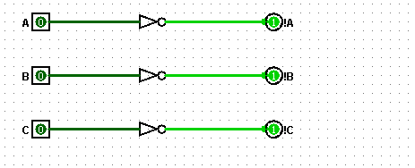

1. Problem: Design a binary converter to convert a 3-bit binary number to a 2’s Complement
2. Solution: I will use the steps learned in class to design a circuit.
3. Create truth table:

|  |  |  |  |  |  |  |
| --- | --- | --- | --- | --- | --- | --- |
| **A** | **B** | **C** | **Carry** | **A 2's** | **B 2's** | **C 2's** |
| 0 | 0 | 0 | 1 | 0 | 0 | 0 |
| 0 | 0 | 1 | 0 | 1 | 1 | 1 |
| 0 | 1 | 0 | 0 | 1 | 1 | 0 |
| 0 | 1 | 1 | 0 | 1 | 0 | 1 |
| 1 | 0 | 0 | 0 | 1 | 0 | 0 |
| 1 | 0 | 1 | 0 | 0 | 1 | 1 |
| 1 | 1 | 0 | 0 | 0 | 1 | 0 |
| 1 | 1 | 1 | 0 | 0 | 0 | 1 |

1. We noticed that we have 3 inputs and 4 outputs
2. Now we create the k-maps:



 

1. Design

